Data Science Training Document

Data
Data is a information about something, it may be structured or unstructured.
Now a days data is mostly collected from IOT.
We can collect the data from multiple sources like facebook,twitter, etc..

Eg. Data about the employees in a company

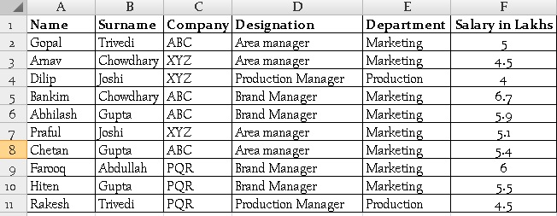

Fig.1.1

Types of Data in Statistics
- Discrete
Discrete data is based on counts
All the countable data will comes under discrete data
For ex:
Take a class room in a college,the total number of students is countable and it
comes under discrete.
- Continuous
All the measurable data in nature it will comes under continuous
Measurable data is with in the selected range.(-1<=x<=1)

For eg.
The height and weight of the student in a class room is continuous
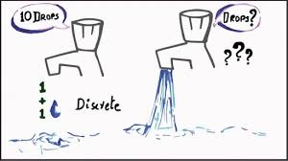

Fig no:1.2

Types of Data
- Primary Data
It's having only one objective
- Secondary Data
It's having multiple obective

Types of Statistics
- Descriptive
- Measure of Central Tendancy
- Measure of Dispersion
- Skeweness
- Kortosis
- Measure of Central Tendancy
  - Mean/Average
  - Median
  - Mode
- Mean / Average
It add together all of the numbers in a dataset and then divide the sum by the total count of numbers.
Eg.
import pandas as pd
d={'marks':[10,20,50,20,78,36]}
df=pd.DataFrame(d)
print(df.mean())
O/P:
marks 35.666667
dtype : float64
For above example the average or mean value has been calculated using mean() inbuilt function in python

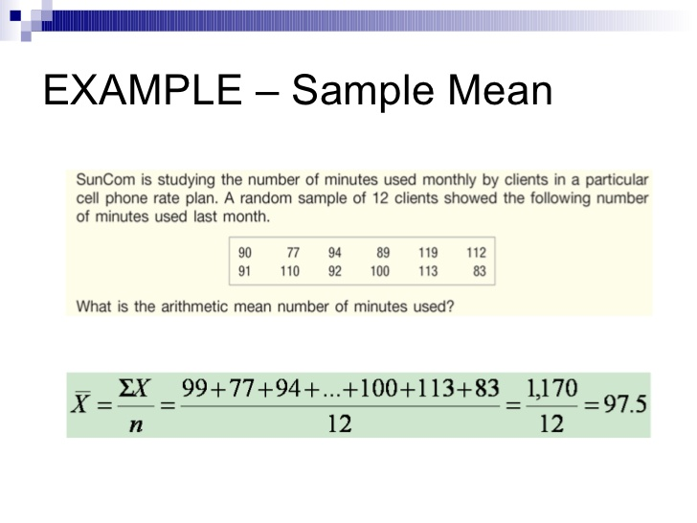

Fig.2.1

- Median
It arranging the data from smallest to largest.
After arranging it takes the middle data in a dataset.
Find the median by averaging the two middle data.
Eg.
import pandas as pd
d={'marks':[10,20,50,20,78,36]}
df=pd.DataFrame(d)
print(df.median())

For above example first the dataframe arranging like[10,20,20,36,50,78]

Then it takes the middle value 20,36, then calculate the median of the dataset.
O/P:
marks 28.0
dtype float64
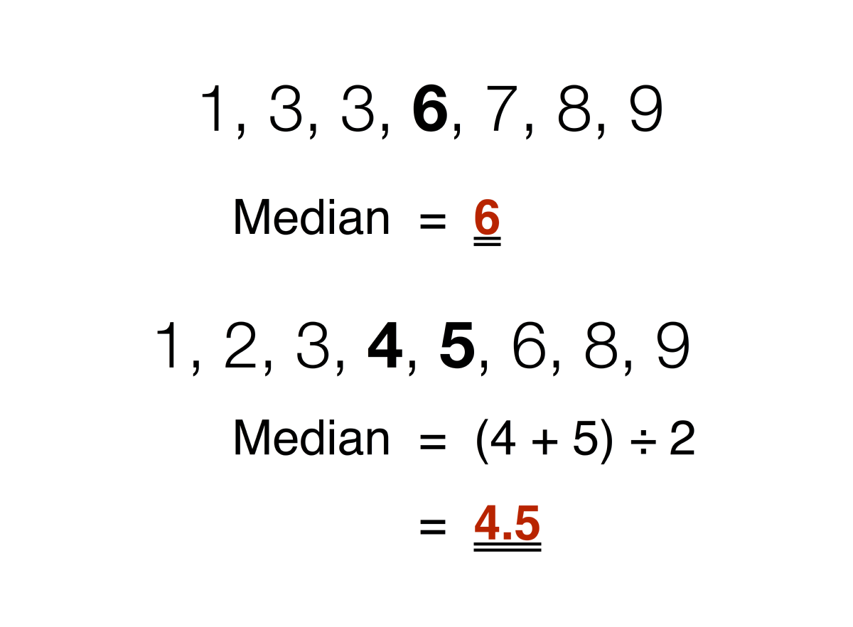

Fig.3.1
- Mode
Its returns the frequently used data one or more time in a dataset.
Eg:
import pandas as pd
d={'marks':[10,20,50,20,78,36]}
df=pd.DataFrame(d)
print(df.mode())
For above example the frequently used value is 20.
So the mode() is returns 20.
O/P: marks 20, dtype float64

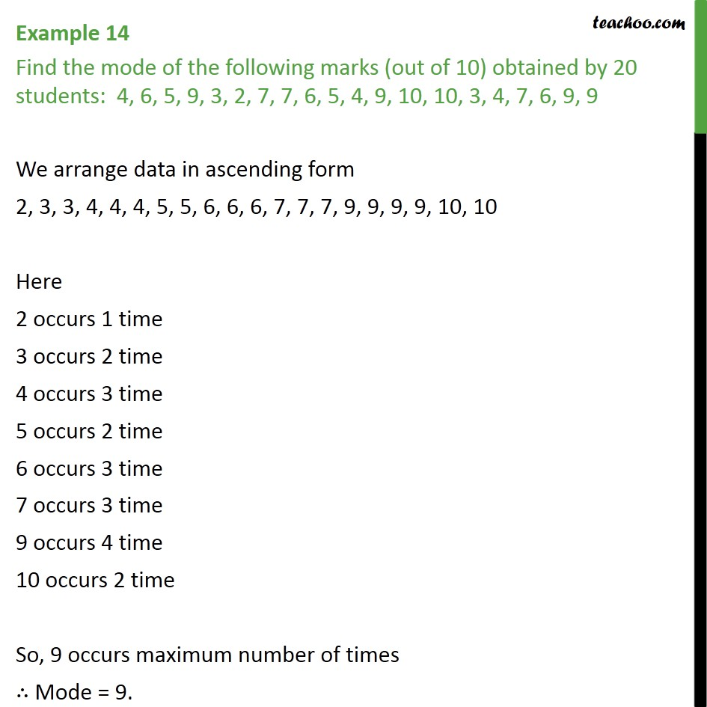

Fig.3.2

- Measure of Dispersion
  - Range
  - Variance
  - Standard Deviation

- Range
Difference between the largest and smallest values.
It takes largest and smallest value from the data set.
Its used only the data less than 6 in a dataset

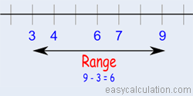

Fig.4.1
- Variance
Variance measures how far a data set is spread out.
Average squared deviation of values from mean.

- Standard Deviation
It takes all data from the dataset.
We can use standars deviation, if the data in a dataset is more than 6.
Standard Deviation is the square root of variance.
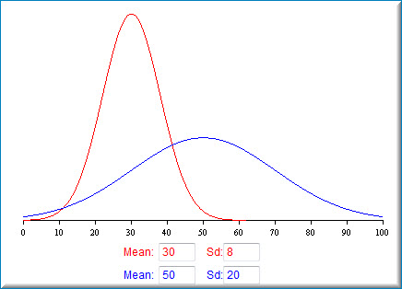

- Skewness
It represents the shape of the distribution.
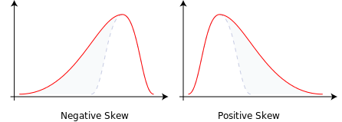
- The mass of the distribution is concentrated on the right of the figure, then its called negative skew.
- the mass of the distribution is concentrated on the left of the figure, then its called positive skew.

- Kurtosis
- Kurtosis is the measure of thickness or heaviness of the given distribution.
- Its actually represents the height of the distribution.
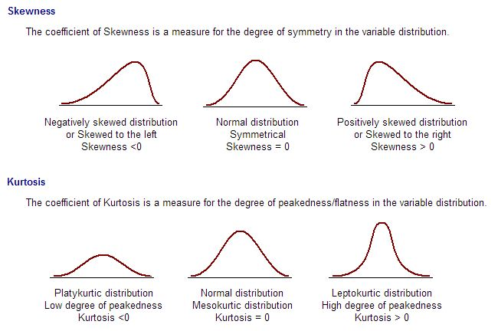

- The distribution with kurtosis equal to 3 is known as mesokurtic. A random variable which follows normal distribution has kurtosis 3.
- If the kurtosis is less than three, the distribution is called as platykurtic. Here, the distribution has shorter and thinner tails than normal distribution.
- If the kurtosis is greater than three, the distribution is called as leptykurtic. Here, the distribution has longer and fatter tails than normal distribution.

